**Fig. 1. Evaluation Metrics of Zero Shot Text Classification**

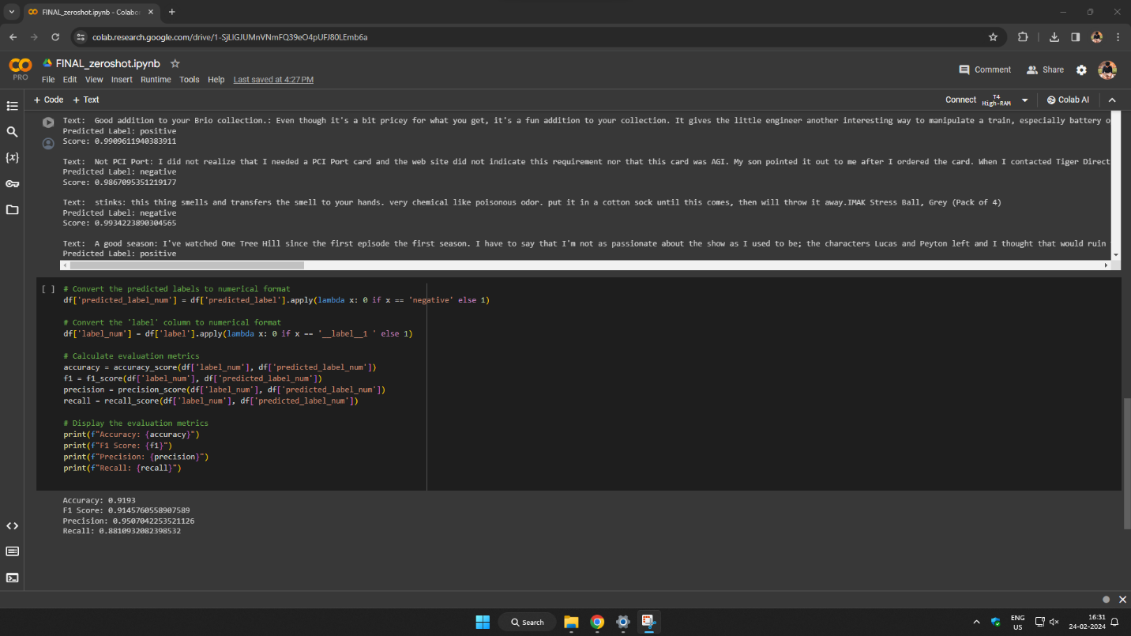

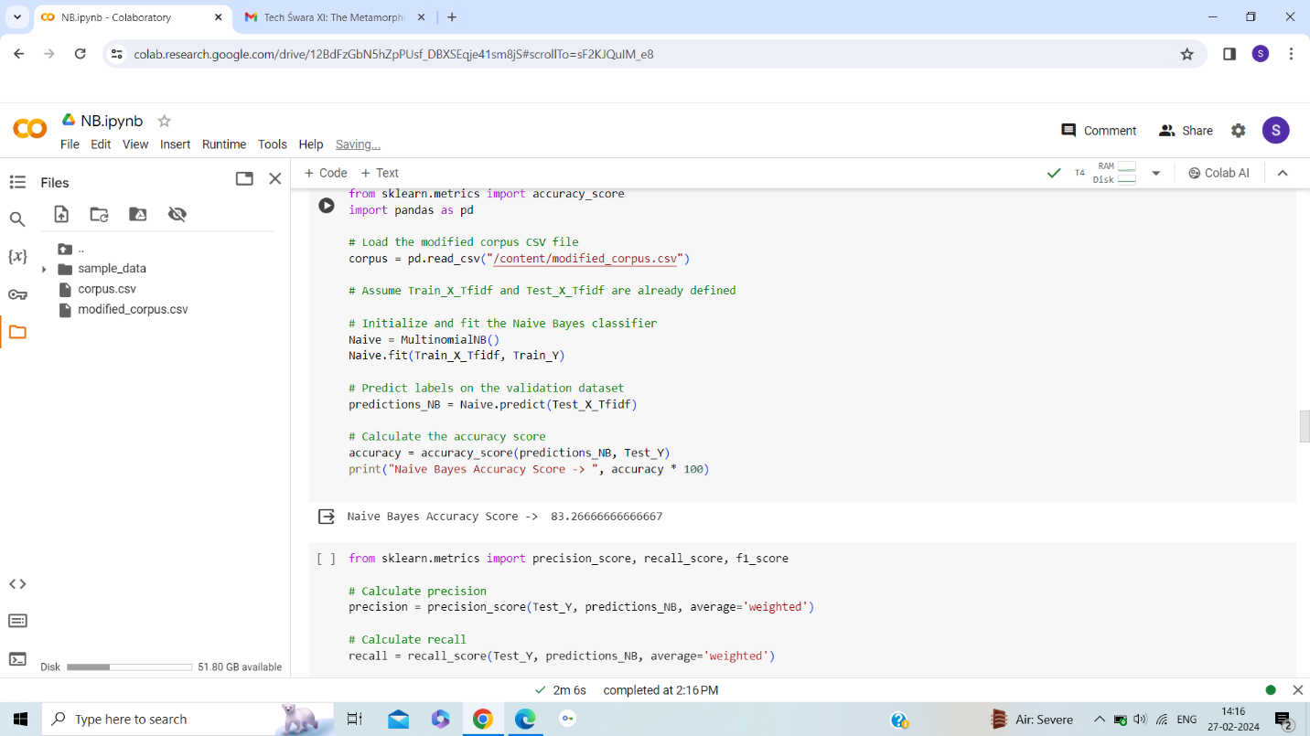

**Fig. 2. Accuracy of Naïve Bayes Text Classification**

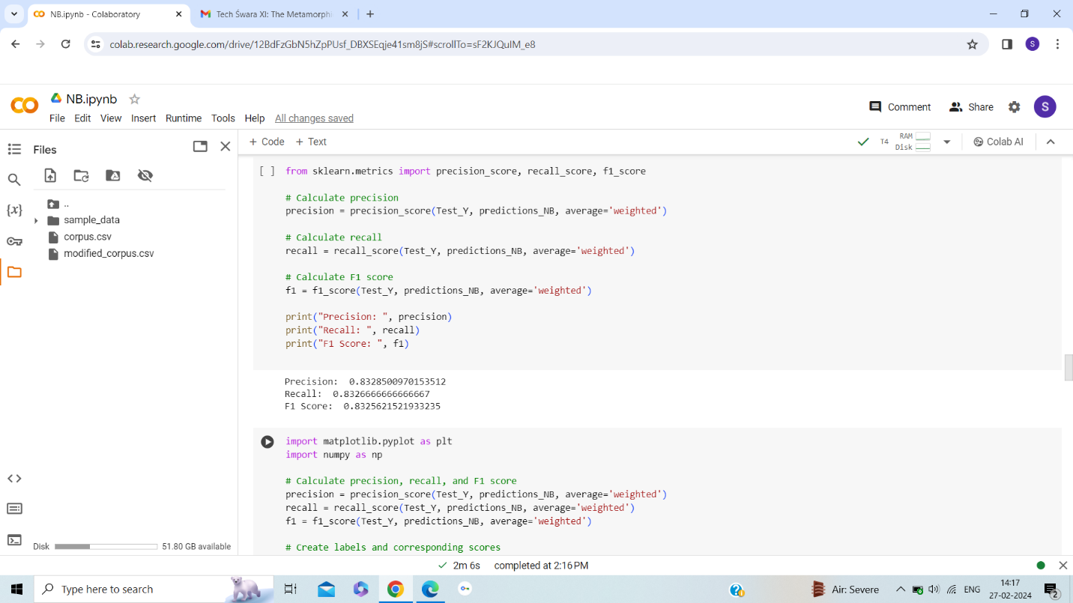

**Fig. 3. F1-score, Precision and Recall of Naïve Bayes Text Classification**

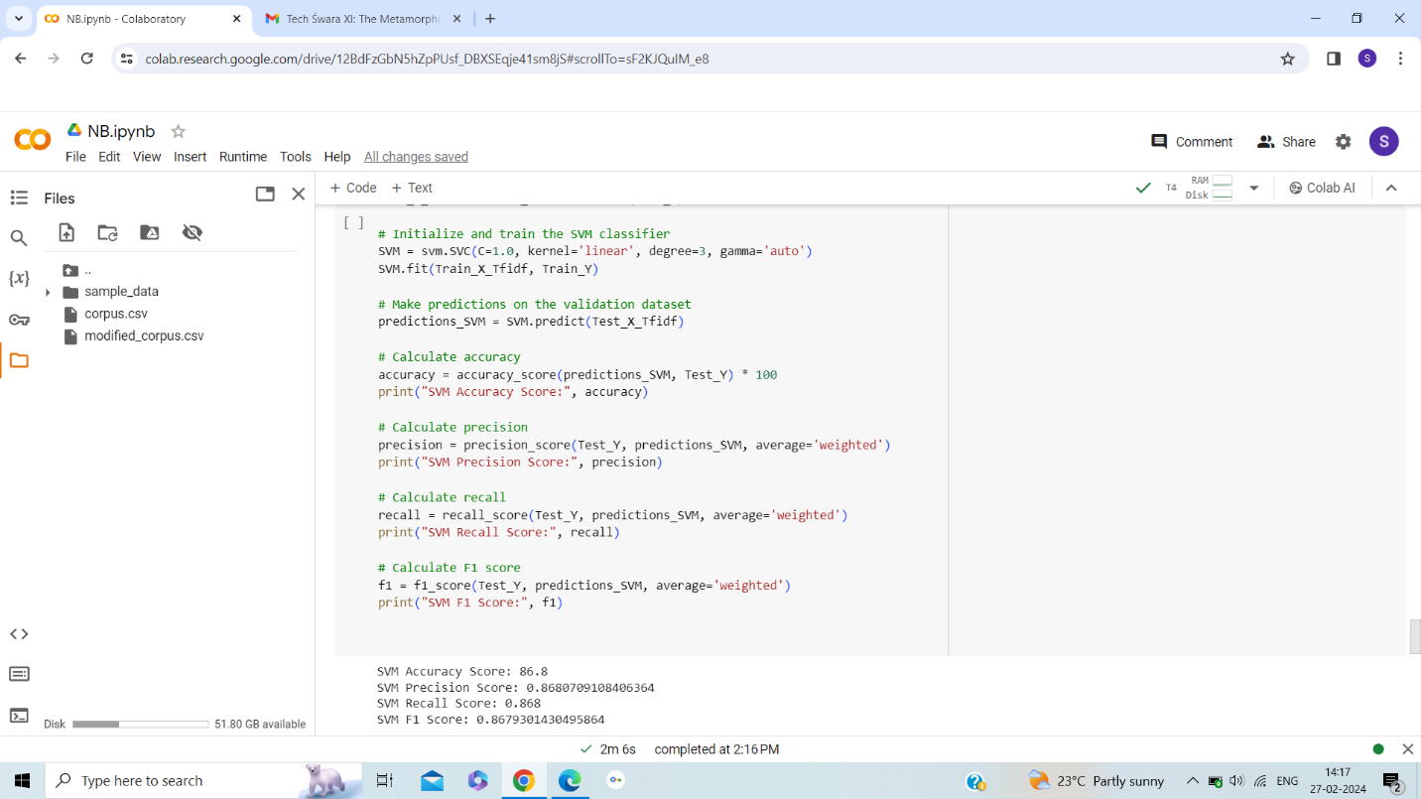

**Fig. 4. Evaluation Metrics of SVM Text Classification**

**Fig. 5. Evaluation Metrics of RNN Text Classification**

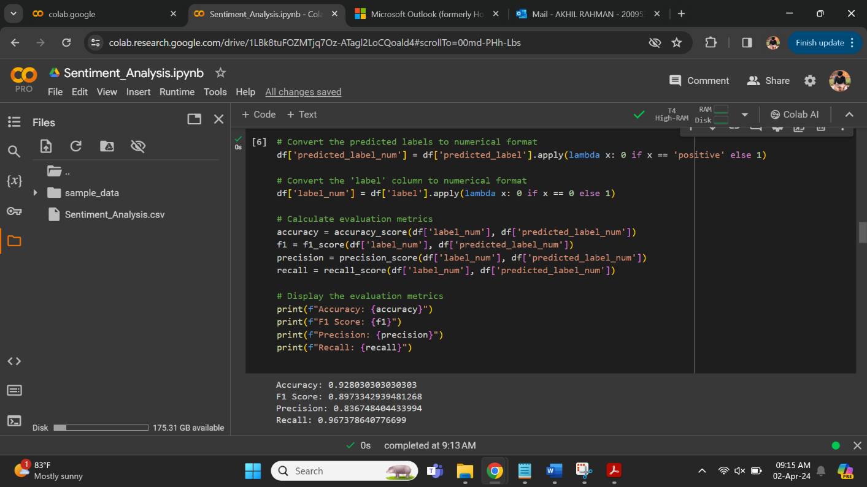

**Fig 6. Evaluation metrics ZSL text classification For Twitter sentiment prediction dataset**

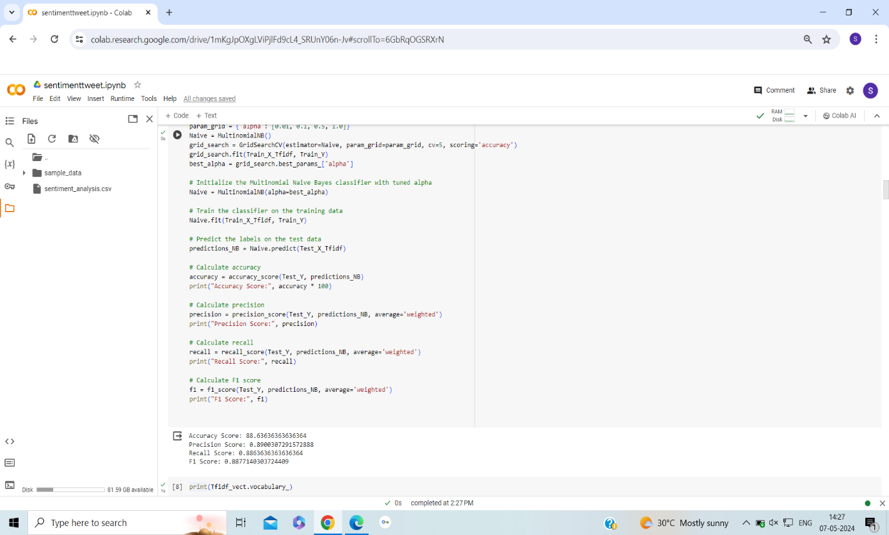

**Fig 7. Naïve bayes Text Classification for Twitter Sentiment Prediction Dataset**

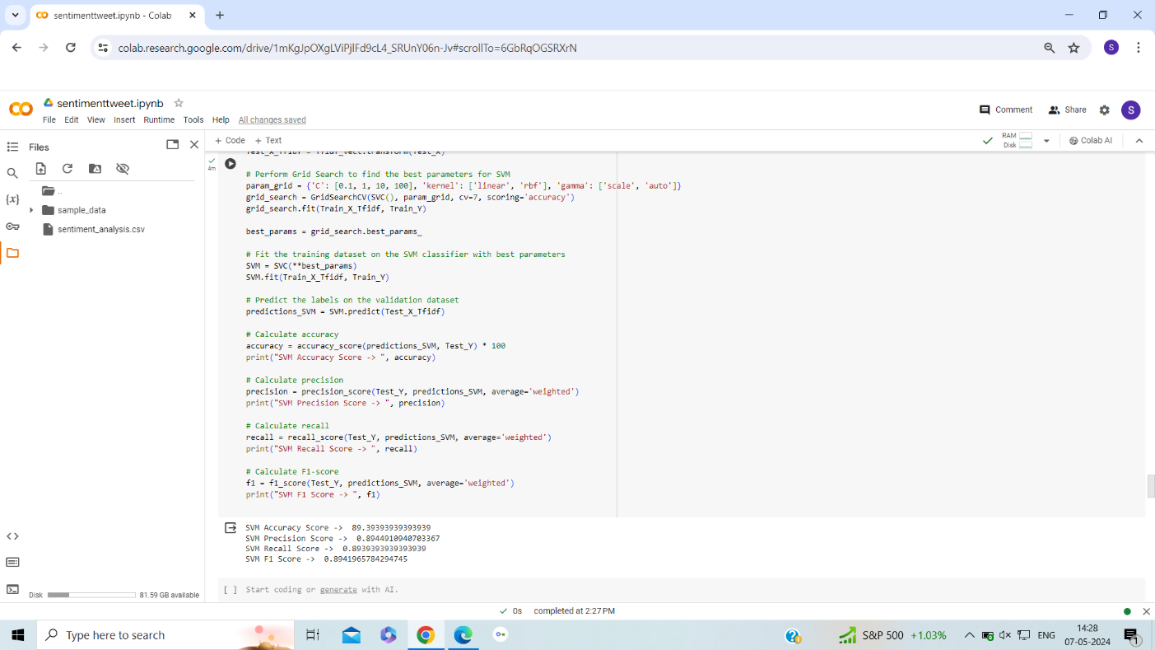

**Fig 8. SVM Text classification For Twitter Sentiment Prediction Dataset**

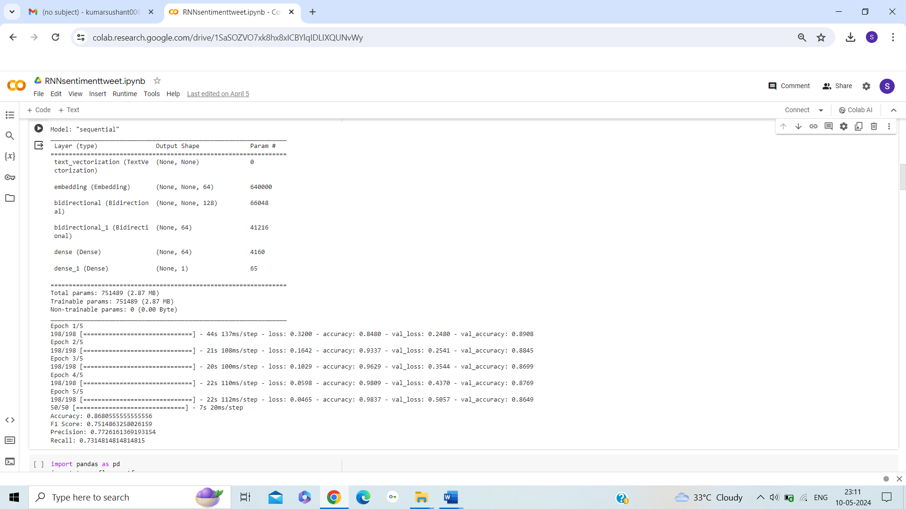

**Fig 9. RNN Text Classification Twitter Sentiment Prediction** **Dataset**

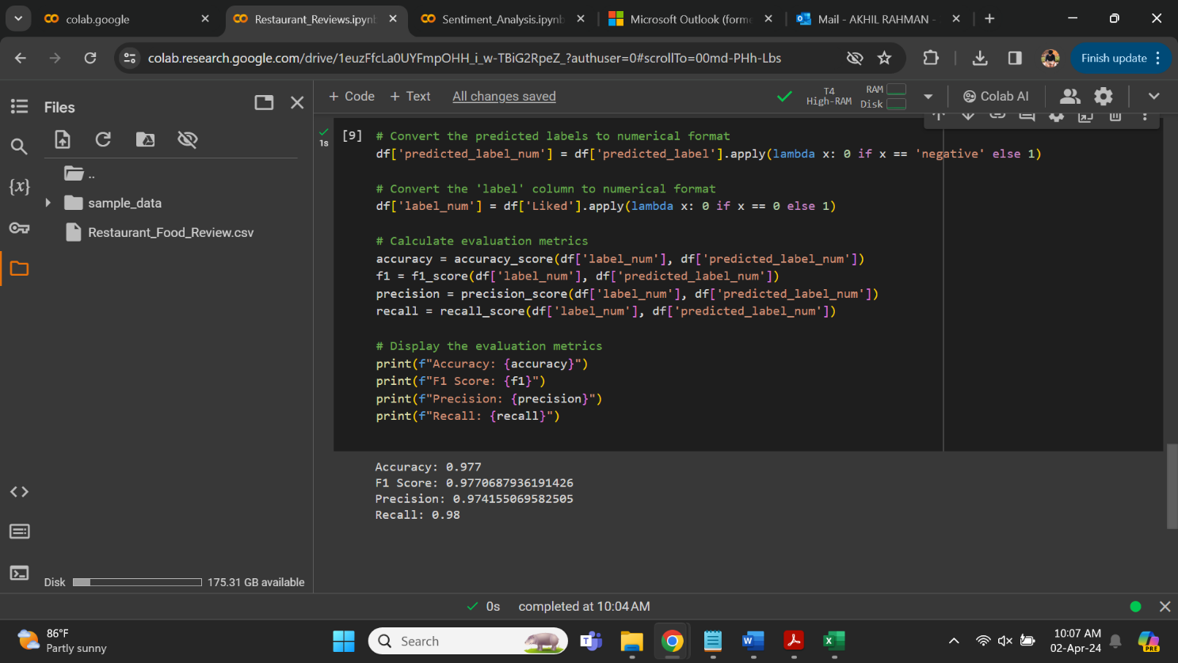

**Fig 10. ZSL Text Classification For Restaurant Food Review Dataset**

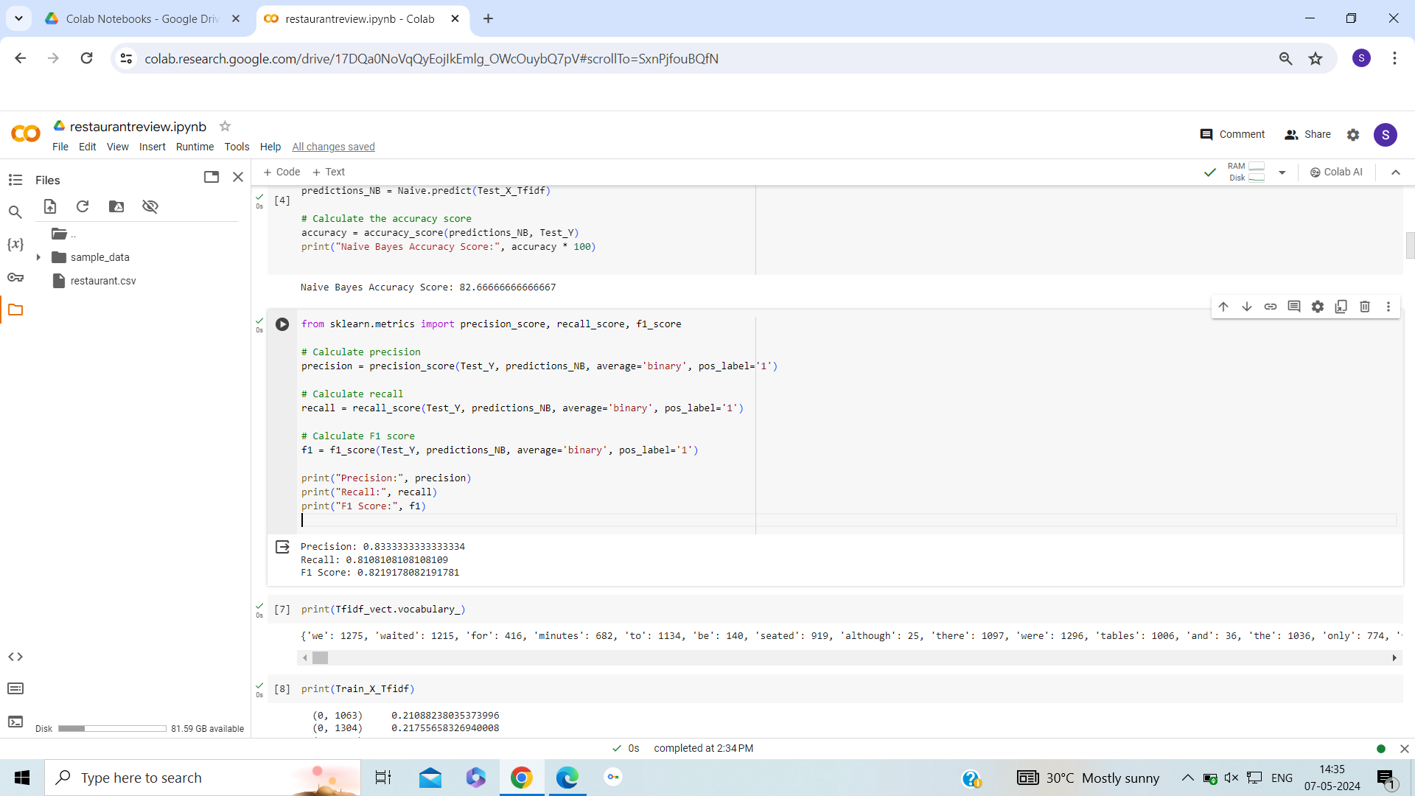

**Fig 11. Naïve Bayes Text Classification For Restaurant Food Review Dataset**

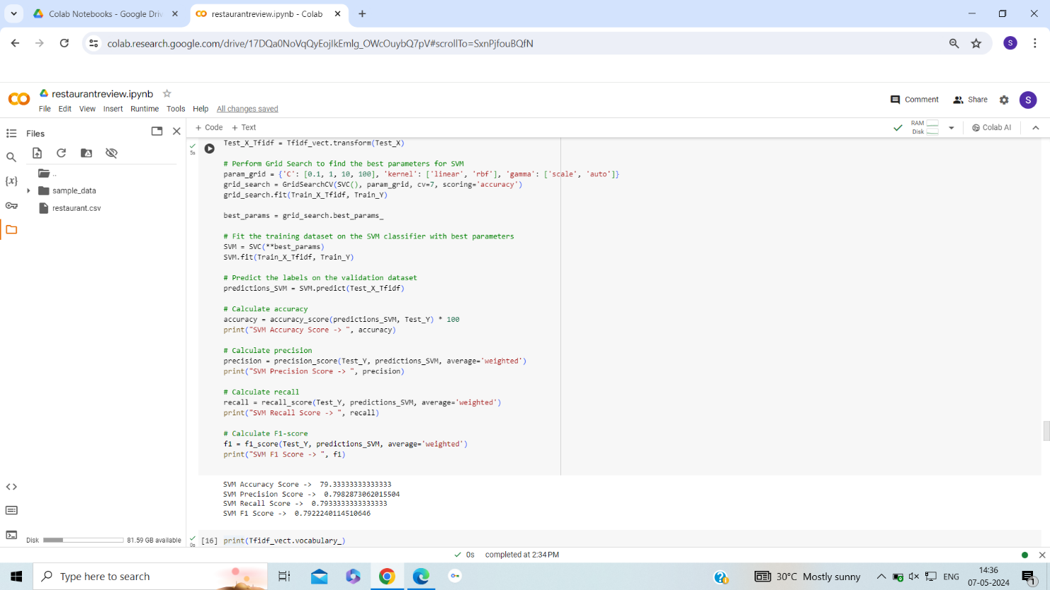

**Fig 12. SVM Text Classification For Restaurant Food Review Dataset**

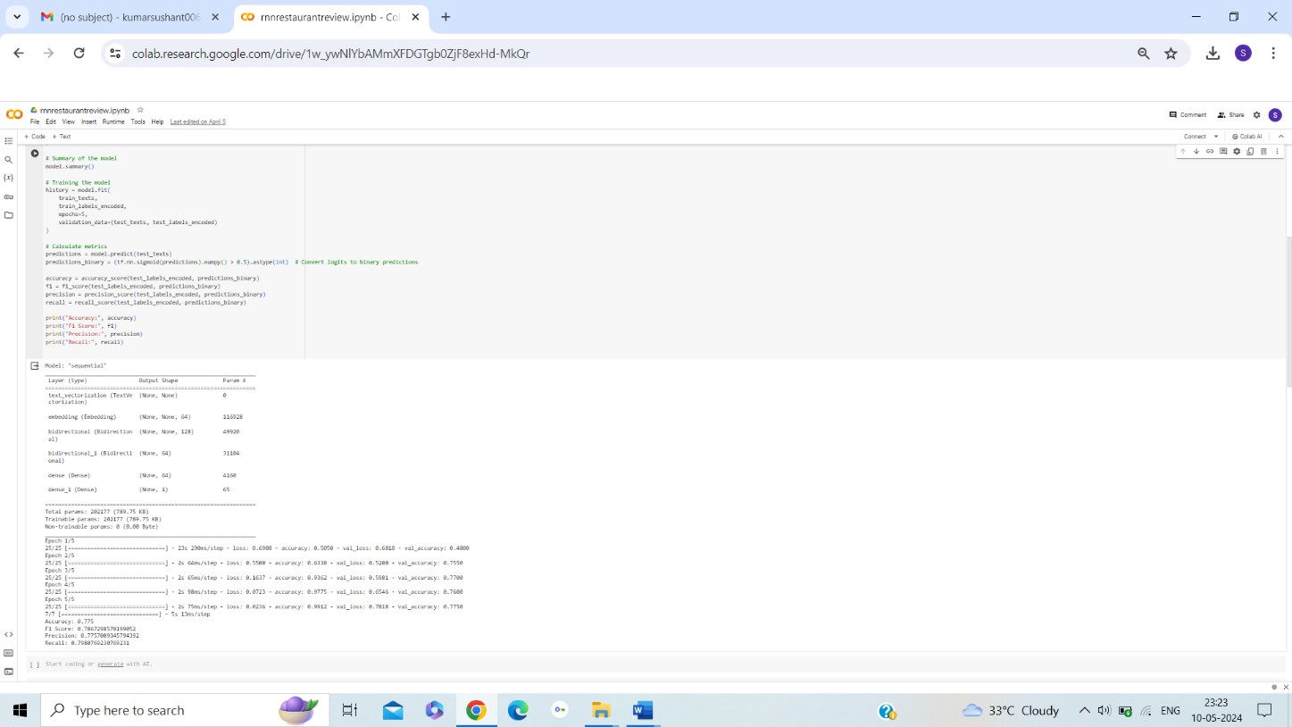

**Fig 13. RNN Text Classification For Restaurant Food Review Dataset**

**DATASET 1 (Amazon Reviews – Sentiment Prediction)**

We have selected the “corpus.csv” dataset which consists of 10000 rows. There are mainly two columns in this dataset:

* “text” column which contains the Amazon reviews.
* “label” column which contains two possible labels: “label_1” if the review is negative or “label_2” if the review is positive. These are the ground truth labels.

|  |  |  |  |  |
| --- | --- | --- | --- | --- |
|  | ZSL | Naïve Bayes | SVM | RNN |
| Accuracy | 0.92 | 0.83 | 0.87 | 0.86 |
| F1-Score | 0.91 | 0.83 | 0.87 | 0.85 |
| Precision | 0.95 | 0.83 | 0.87 | 0.86 |
| Recall | 0.88 | 0.83 | 0.87 | 0.84 |

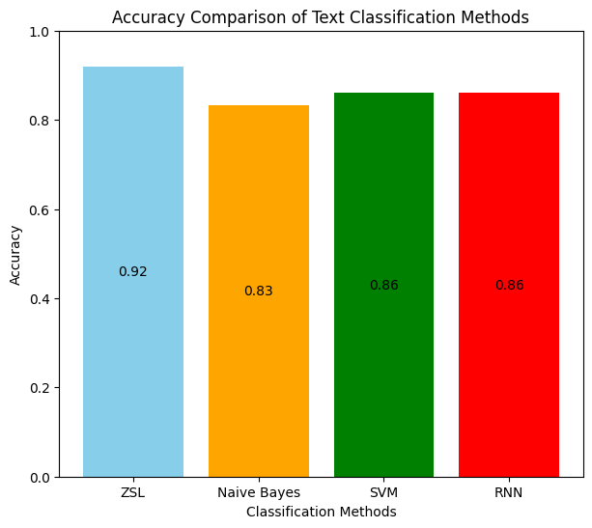

**Accuracy Bar Graph Plot of ZSL vs Supervised Text Classification Methods**

**Precision, Recall and F1-Score Bar Graph Plot of ZSL vs Supervised Text Classification Methods**

**DATASET 2 ( Twitter Data – Sentiment Prediction)**

We have selected the “Sentiment_Analysis.csv” dataset which consists of 7920 rows. There are three columns in this dataset:

* “id” column which contains the row number.
* “label” column which contains two possible labels: “1” if the review is negative or “0” if the review is positive. These are the ground truth labels.
* “’tweet” column which contains the users’ tweets.

|  |  |  |  |  |
| --- | --- | --- | --- | --- |
|  | ZSL | Naïve Bayes | SVM | RNN |
| Accuracy | 0.93 | 0.89 | 0.89 | 0.87 |
| F1-Score | 0.90 | 0.89 | 0.89 | 0.75 |
| Precision | 0.84 | 0.89 | 0.89 | 0.80 |
| Recall | 0.97 | 0.89 | 0.89 | 0.71 |

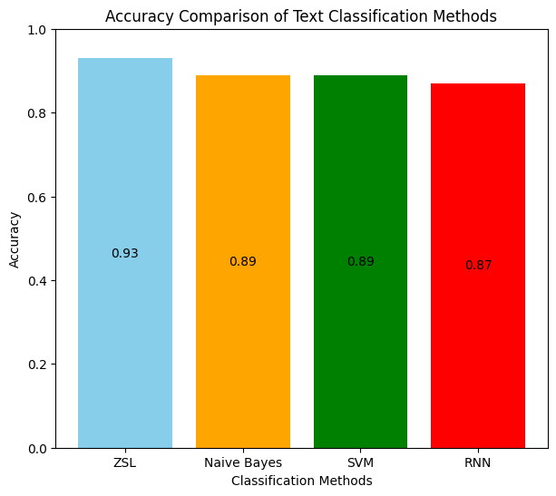

**Accuracy Bar Graph Plot of ZSL vs Supervised Text Classification Methods**

**Precision, Recall and F1-Score Bar Graph Plot of ZSL vs Supervised Text Classification Methods**

**DATASET 3 (Restaurant Food Reviews – Sentiment Prediction)**

We have selected the “Restaurant_Food_Reviews.csv” dataset which consists of 1000 rows. There are two columns in this dataset:

* “Review” column which contains restaurant food/service review.
* “Liked” column which contains two possible labels: “0” if the review is negative or “1” if the review is positive. These are the ground truth labels.

|  |  |  |  |  |
| --- | --- | --- | --- | --- |
|  | ZSL | Naïve Bayes | SVM | RNN |
| Accuracy | 0.98 | 0.83 | 0.79 | 0.78 |
| F1-Score | 0.98 | 0.82 | 0.79 | 0.77 |
| Precision | 0.97 | 0.83 | 0.80 | 0.78 |
| Recall | 0.98 | 0.81 | 0.79 | 0.80 |

**Accuracy Bar Graph Plot of ZSL vs Supervised Text Classification Methods**

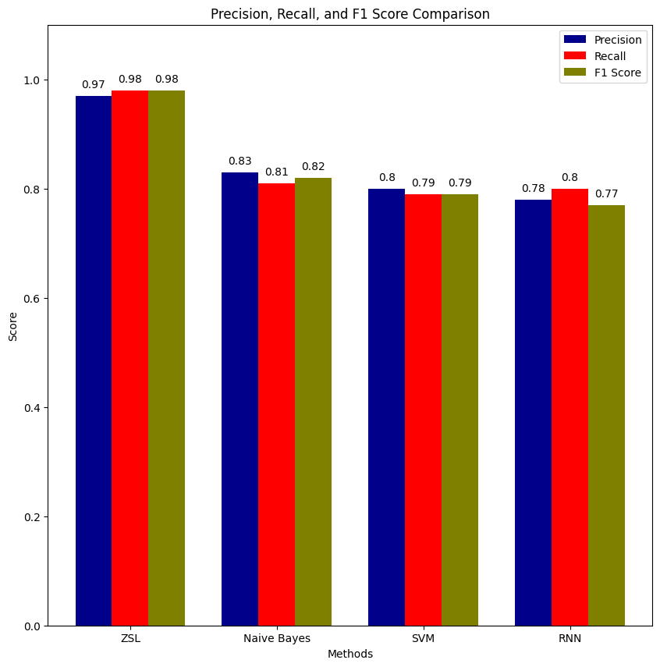

**Precision, Recall and F1-Score Bar Graph Plot of ZSL vs Supervised Text Classification Met**

**Chapter 7**

**Real Life Application of Zero Shot Text Classification**

We have adopted zero-shot text classification predominantly for its application in sentiment analysis. This approach enables us to analyze text data without the need for pre-defined categories, allowing for a more flexible and efficient sentiment analysis process. By focusing on sentiment analysis, we aim to leverage the efficiency of zero-shot text classification to gain deeper insights into customer perceptions, identify emerging trends, and drive proactive actions to optimize customer satisfaction and brand reputation.

Real-life applications of zero-shot text classification in sentiment analysis include:

* Analyzing user comments and posts on social media platforms to evaluate public opinion about products, services, or events.
* Automatically categorizing customer feedback into positive and negative sentiments to identify areas for improvement.
* Analyzing product reviews to understand customer satisfaction levels and make informed decisions about product improvements.
* Analyzing textual data from surveys, interviews, or focus groups to understand consumer preferences and market trends.

**Chapter 8**

**Sustainable Development Goals – SDG**

* **SDG 3 – Good Health and Well-Being**

Data can be sourced from social media posts, news articles, surveys, or public health reports. These sources contain a variety of opinions and discussions about healthcare initiatives and access to quality healthcare. Zero-shot text classification is applied to categorize the collected texts into positive and negative sentiments. The model does this without being explicitly trained on examples from the healthcare domain, relying on its pre-trained understanding of language and sentiment.

* **SDG 8 – Decent Work and Economic Growth**

Textual data can be collected from social media posts, news articles, economic reports, and surveys. These texts may contain opinions, feedback, or discussions related to job creation, unemployment, and job insecurity. The analysis provides insights into public sentiment towards job creation, unemployment, and job insecurity, highlighting areas of concern and potential actions to improve job market conditions. For example, if there are many negative sentiments regarding job insecurity, policymakers and employers may consider measures to enhance job security and stability.

**Chapter 7**

**Real Life Application of Zero Shot Text Classification**

We have adopted zero-shot text classification predominantly for its application in sentiment analysis. This approach enables us to analyze text data without the need for pre-defined categories, allowing for a more flexible and efficient sentiment analysis process. By focusing on sentiment analysis, we aim to leverage the efficiency of zero-shot text classification to gain deeper insights into customer perceptions, identify emerging trends, and drive proactive actions to optimize customer satisfaction and brand reputation.

Real-life applications of zero-shot text classification in sentiment analysis include:

* Analyzing user comments and posts on social media platforms to evaluate public opinion about products, services, or events.
* Automatically categorizing customer feedback into positive and negative sentiments to identify areas for improvement.
* Analyzing product reviews to understand customer satisfaction levels and make informed decisions about product improvements.
* Analyzing textual data from surveys, interviews, or focus groups to understand consumer preferences and market trends.

**Chapter 8**

**Sustainable Development Goals – SDG**

* **SDG 3 – Good Health and Well-Being**

Data can be sourced from social media posts, news articles, surveys, or public health reports. These sources contain a variety of opinions and discussions about healthcare initiatives and access to quality healthcare. Zero-shot text classification is applied to categorize the collected texts into positive and negative sentiments. The model does this without being explicitly trained on examples from the healthcare domain, relying on its pre-trained understanding of language and sentiment.

* **SDG 8 – Decent Work and Economic Growth**

Textual data can be collected from social media posts, news articles, economic reports, and surveys. These texts may contain opinions, feedback, or discussions related to job creation, unemployment, and job insecurity. The analysis provides insights into public sentiment towards job creation, unemployment, and job insecurity, highlighting areas of concern and potential actions to improve job market conditions. For example, if there are many negative sentiments regarding job insecurity, policymakers and employers may consider measures to enhance job security and stability.

# Appendices

# References

[1] Sivarajkumar, S., & Wang, Y. (2023). Evaluation of Healthprompt for zero-shot clinical text classification. [Paper presented at the International Conference on Intelligent Computing and Health (ICICH), pp. 1-6].

[2] Basu, S., Campbell, R. H., & Karahalios, K. (2023). Detection of novel COVID-19 variants with zero-shot learning. [Paper presented at the International Conference on Intelligent Computing and Health (ICICH), pp. 1-6].

[3] Dan et al. (2022). Enhancing class understanding via prompt-tuning for zero-shot text classification. [Paper presented at the International Conference on Signal Processing (ICASP), pp. 1-5].

[4] Patadia et al. (2023). Zero-shot approach for news and scholarly article classification.

[5] Chong, W. J., Chua, H. N., & Gan, M. F. (2022). Comparing zero-shot text classification and rule-based matching in identifying cyberbullying behaviors on social media. In Proceedings of the 2022 IEEE International Conference on Artificial Intelligence in Engineering and Technology (IICAIET), pp. 1-5. [DOI 10.1109/IICAIET55139.2022.99369]

[6] Wang, Y., Wang, W., Chen, Q., Huang, K., Nguyen, A., & De, S. (2022). Generalised Zero-shot Learning for Entailment-based Text Classification with External Knowledge, pp. 1-7].

[7] Li, J., Chen, Q., Wang, W., & Wu, F. (2023). Knowledge-embedded Prompt Learning for Zero shot Social Media Text Classification, pp. 1-3].

[8] Palaniappan, M., Vedhamani, A., & Sundharakumar, K. B. (2023). Zero-Shot Learning for Text Classification: Extending Classifiability Beyond Conventional Techniques, pp. 1-6].

[9] Kasthuriarachchy, B., Chetty, M., Shatte, A., & Walls, D. (2023). Cost Effective Annotation Framework Using Zero-Shot Text Classification, pp. 1-8].

[10] Zhang, Y., Yuan, C., & Wang, X. (2023). Generalized Zero-Shot Text Classification via Inter Class Relationship. Beijing University of Posts and Telecommunications, Beijing, China, pp. 1-5].

*Student Details*

Table B.1: Project Detail

|  |  |  |  |
| --- | --- | --- | --- |
| **Student Name** | Your Name | | |
| Registration  Number | 160911xxx | Section/Roll No. | A/01 |
| Email Address | [xyz@gmail.com](mailto:xyz@gmail.com) | Phone No.(M) | 9891000000 |
| **Student Name** | Your Name | | |
| Registration  Number | 160911001 | Section/Roll No. | A/01 |
| Email Address | [yourname@yahoo.com](mailto:yourname@yahoo.com) | Phone No.(M) | 9891000000 |

*Project Details*

|  |  |  |  |
| --- | --- | --- | --- |
| **Project Title** | Title of your project | | |
| Project Duration | 4-6 Months | Date of Reporting | dd-mm-2020 |

*Organization Details*

|  |  |
| --- | --- |
| **Organization**  **Name** | Name of your organization |
| Full Postal Ad-  dress | Whitefield, B’lore |
| Website Address | [www.abc.com](http://www.abc.com/) |

*Supervisor Details*

|  |  |  |  |
| --- | --- | --- | --- |
| **Supervisor Full**  **Name** | Name | | |
| Designation | Project Leader or Manager | | |
| Full Contact Ad- dress with PIN  Code | #1,Whitefield, B’lore | | |
| Email Address | [xyz@abc.in](mailto:xyz@abc.in) | Phone No.(M) | 9767541234 |

*Internal Guide Details*

|  |  |
| --- | --- |
| **Faculty Name** | Name |
| Full Contact Ad- dress with PIN  Code | Department of Information and Communication Technology, Manipal Institute of Technology, Manipal-576104 |
| Email Address | [abc@manipal.edu](mailto:abc@manipal.edu) |